**Servlet and JSP**

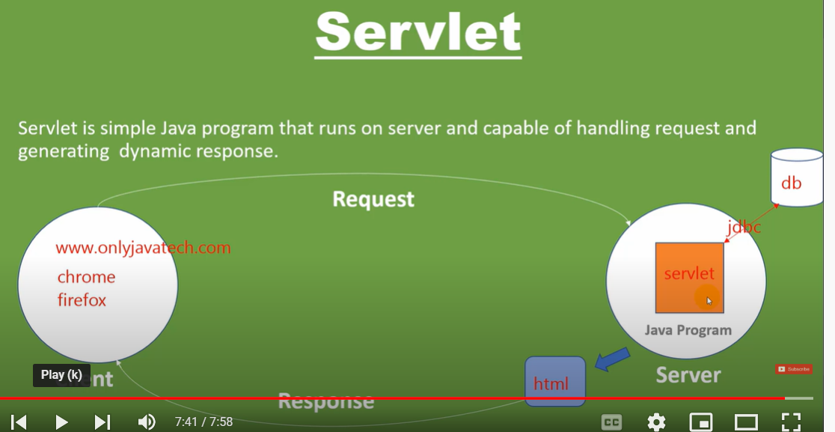

**Why we need Servlet and JSPs?**

Web servers are good for static contents HTML pages but they don’t know how to generate dynamic content or how to save data into databases, so we need another tool that we can use to generate dynamic content. There are several programming languages for dynamic content like PHP, Python, Ruby on Rails, Java Servlets and JSPs. Java Servlet and JSPs are server-side technologies to extend the capability of web servers by providing support for dynamic response and data persistence.

### First Web Application with Servlet and JSP

We will use “Eclipse IDE for Java EE Developers” for creating our first servlet application. Since servlet is a server-side technology, we will need a web container that supports Servlet technology, so we will use the Apache Tomcat server. It’s very easy to set up and I am leaving that part to yourself. For ease of development, we can add configure Tomcat with Eclipse, it helps in easy deployment and running applications. Go to Eclipse Preference and select Server Runtime Environments and select the version of your tomcat server, mine is Tomcat 7.